Rules for using the iPad Center
- Wash your hands before using the iPad.
- No water near the iPad.
- Use only apps in the instructions for the center.
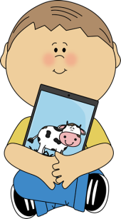
- Always share with others in your group.
- Be gentle when touching the screen.
- Leave the iPad on the table unless you are taking a picture.

